────────────────────────────────────────
LLM-Based Veterinary Radiology
Report Classification
A Multi-Model, Multi-Strategy Comparative Analysis
────────────────────────────────────────

Project Report
March 2026

1. Executive Summary
This report presents a Large Language Model (LLM) pipeline for automated classification of veterinary radiology reports. The system classifies radiologist-written reports as Normal or Abnormal across dozens of clinical conditions, enabling scalable data labeling for downstream model training.
Two models were evaluated—OpenAI GPT-4o-mini and Google Gemini 2.5 Flash—across three prompting strategies (Full Prompt, Lean Prompt, and Two-Pass) on 200 manually labeled radiology reports spanning 51 conditions across canine thorax, canine abdomen, and feline thorax categories.
Bottom line: Gemini 2.5 Flash with Full Prompt achieved the highest average accuracy (98.3%), outperforming GPT-4o-mini (97.5%) at comparable cost ($0.068 vs $0.072 per run). The entire pipeline requires no custom NER models, no keyword dictionaries, and no negation detection logic—only structured prompts and API calls.

2. System Overview

2.1 Pipeline Architecture
The pipeline sends each radiology report (FINDINGS + CONCLUSIONS) to an LLM along with condition definitions extracted from expert-labeled column headers. The model returns structured JSON classifications (Abnormal/Normal) for all conditions simultaneously in a single API call.
- Config-driven design — prompts and settings in JSON; no code changes to tune.
- Modular prompt assembly — base instructions + species context + cross-condition rules + disambiguation + edge-case overrides.
- Async concurrent scoring — asyncio with semaphore rate-limiting (N=10) and exponential backoff.
- Structured output — OpenAI JSON Schema (strict); Gemini response_mime_type="application/json".

2.2 Prompting Strategies
Full Prompt: All rule categories including edge-case overrides from iterative error analysis.
Lean Prompt: Omits edge-case overrides; tests generalization without hand-tuned exceptions.
Two-Pass: Pass 1 uses Lean Prompt with confidence scoring. Cases below 0.75 confidence are re-scored with Full Prompt in Pass 2.

3. Models Evaluated
Property | GPT-4o-mini | Gemini 2.5 Flash
Provider | OpenAI | Google
Input Price (per 1M tokens) | $0.15 | $0.15
Output Price (per 1M tokens) | $0.60 | $0.60
Structured Output | JSON Schema (strict) | response_mime_type=json
Temperature | 0 | 0

4. Validation Results

4.1 Overall Accuracy
Accuracy is the percentage of correct Abnormal/Normal classifications across all condition–report pairs, compared against radiologist ground-truth labels.

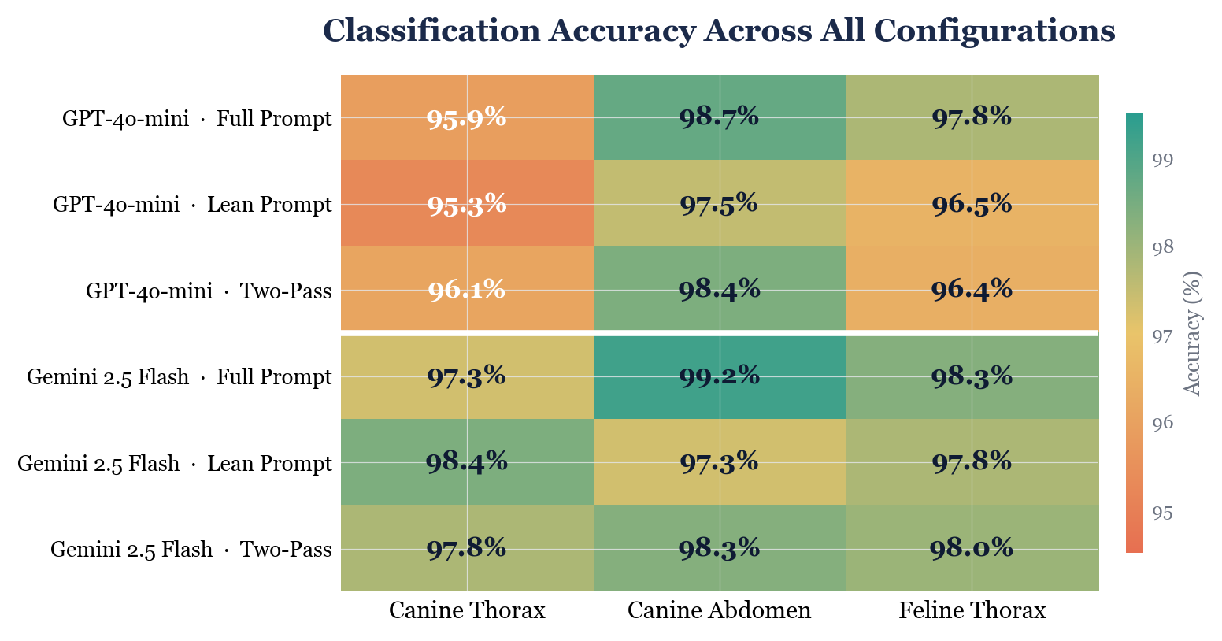
Figure 1. Classification accuracy heatmap across all 18 configurations.
Model | Approach | Canine Thorax | Canine Abdomen | Feline Thorax | Average
GPT-4o-mini | Full Prompt | 95.9% | 98.7% | 97.8% | 97.5%
GPT-4o-mini | Lean Prompt | 95.3% | 97.5% | 96.5% | 96.4%
GPT-4o-mini | Two-Pass | 96.1% | 98.4% | 96.4% | 97.0%
Gemini 2.5 Flash | Full Prompt | 97.3% | 99.2% | 98.3% | 98.3%
Gemini 2.5 Flash | Lean Prompt | 98.4% | 97.3% | 97.8% | 97.8%
Gemini 2.5 Flash | Two-Pass | 97.8% | 98.3% | 98.0% | 98.0%

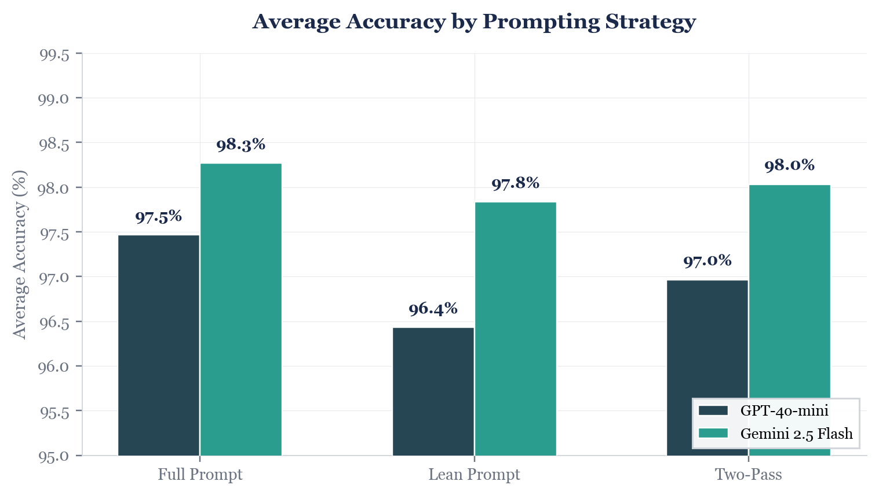
Figure 2. Average accuracy by model and prompting strategy.

4.2 Peak Performance per File Type

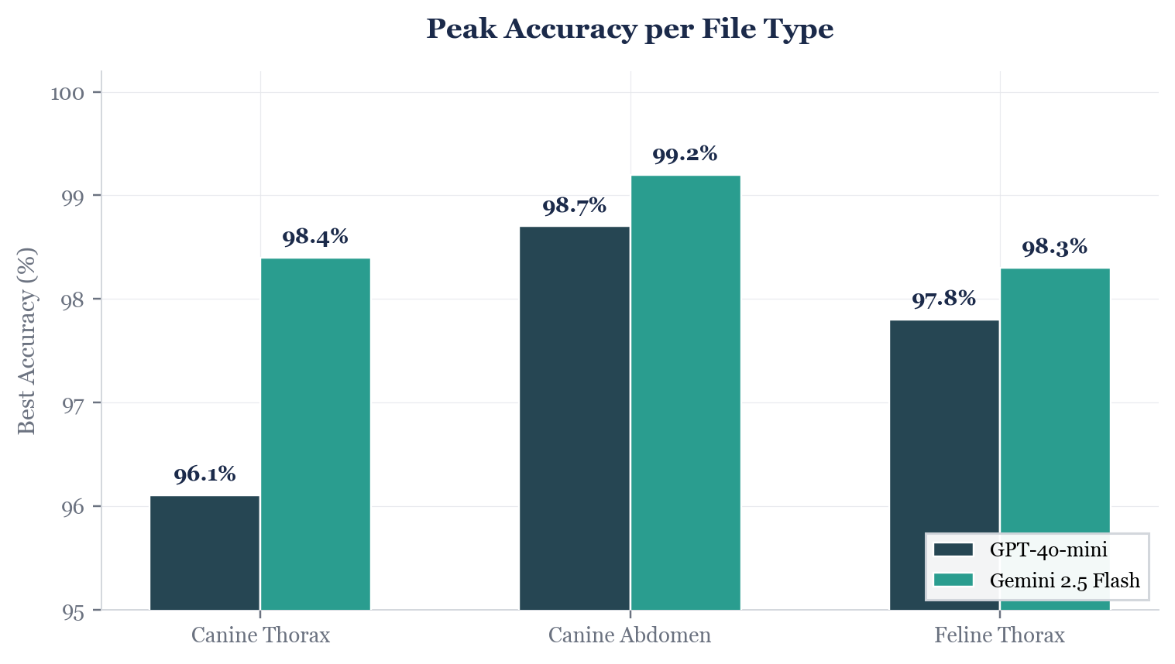
Figure 3. Best accuracy achieved per file type across all approaches.

4.3 Key Observations
- Gemini 2.5 Flash outperformed GPT-4o-mini in 7 of 9 file-type/approach combinations.
- Full Prompt was the best strategy for GPT-4o-mini on 2 of 3 file types, confirming that condition-specific edge-case rules help this model.
- Gemini achieved its highest single-file accuracy (98.4%) with the Lean Prompt on Canine Thorax, suggesting stronger generalization.
- Two-Pass did not consistently outperform Full Prompt for either model despite higher cost.
- Canine Abdomen achieved the highest accuracy (97.3–99.2%) across all configs, likely due to fewer ambiguous conditions.
- All configurations exceeded 95% accuracy, with the best reaching 99.2% on a single file type.

5. Cost Analysis

5.1 Per-Run Costs
Model | Approach | Input Tokens | Output Tokens | Total | Cost (USD) | Per Report
GPT-4o-mini | Full | 369,642 | 26,924 | 396,566 | $0.0716 | $0.00036
GPT-4o-mini | Lean | 338,717 | 26,898 | 365,615 | $0.0669 | $0.00033
GPT-4o-mini | Two-Pass | 453,249 | 76,006 | 529,255 | $0.1136 | $0.00057
Gemini | Full | 289,397 | 40,149 | 329,546 | $0.0675 | $0.00034
Gemini | Lean | 261,472 | 40,163 | 301,635 | $0.0633 | $0.00032
Gemini | Two-Pass | 447,855 | 152,728 | 600,583 | $0.1588 | $0.00079

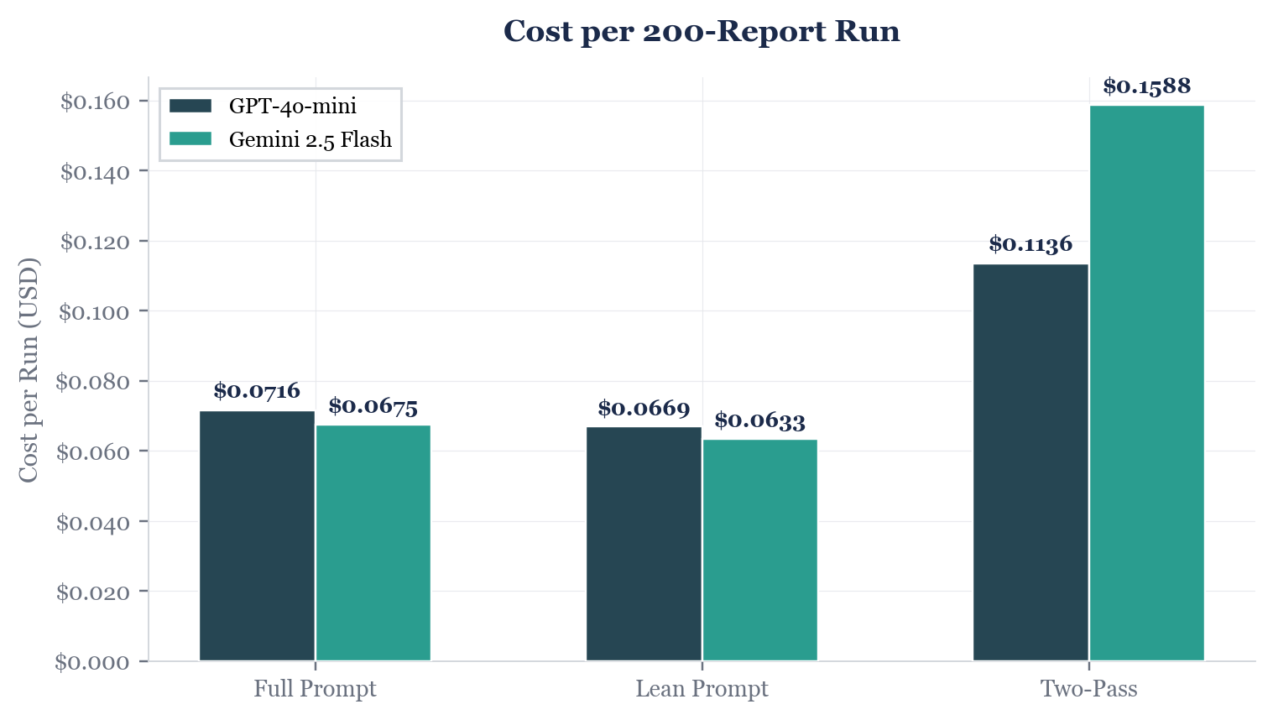
Figure 4. Total cost per 200-report run by model and strategy.

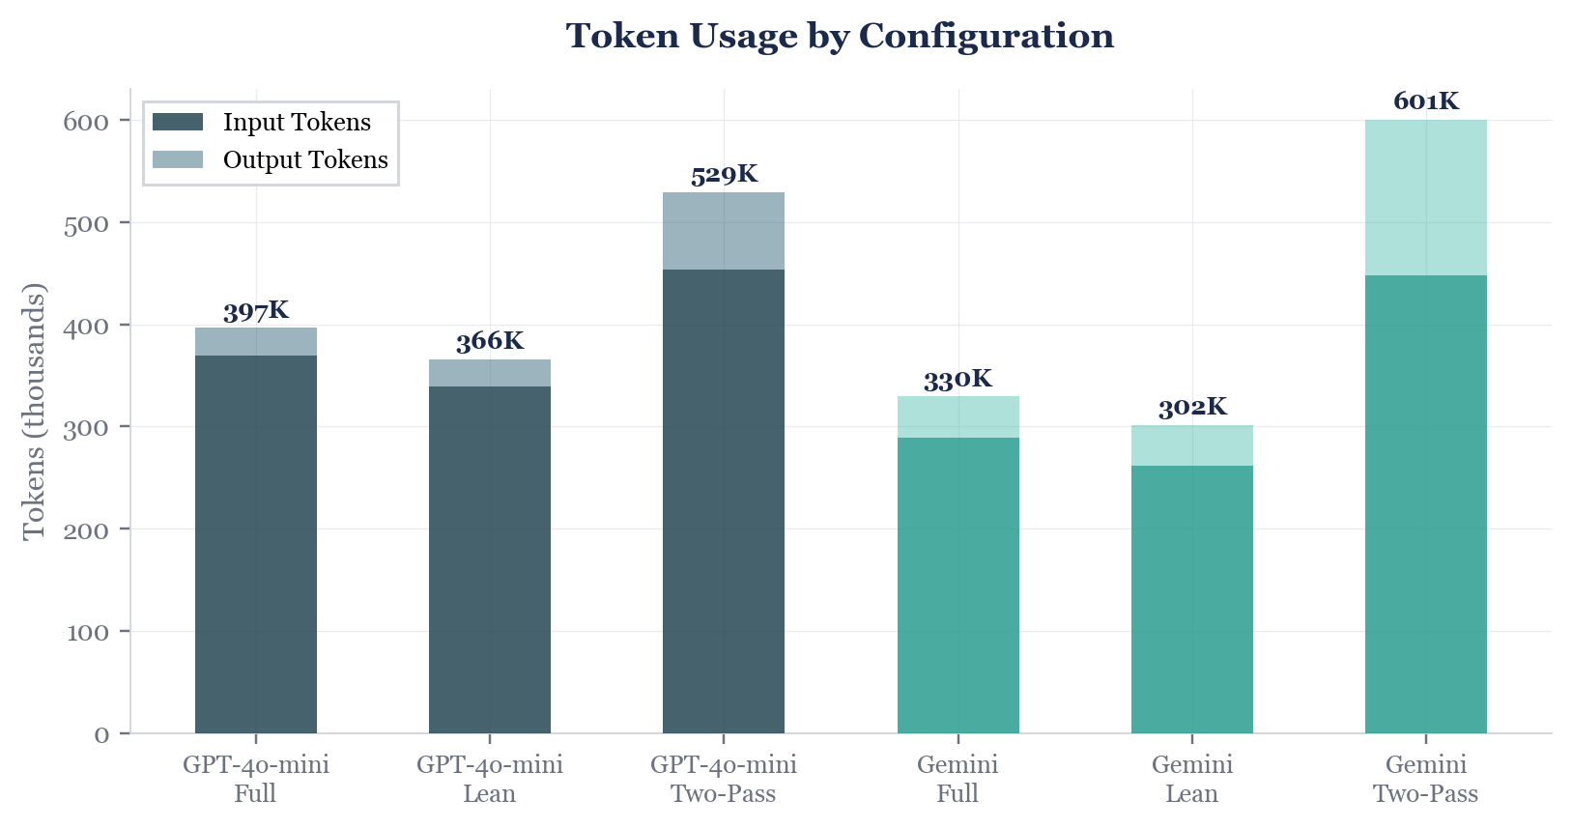
Figure 5. Token usage breakdown (input vs. output) by configuration.

5.2 Accuracy–Cost Tradeoff

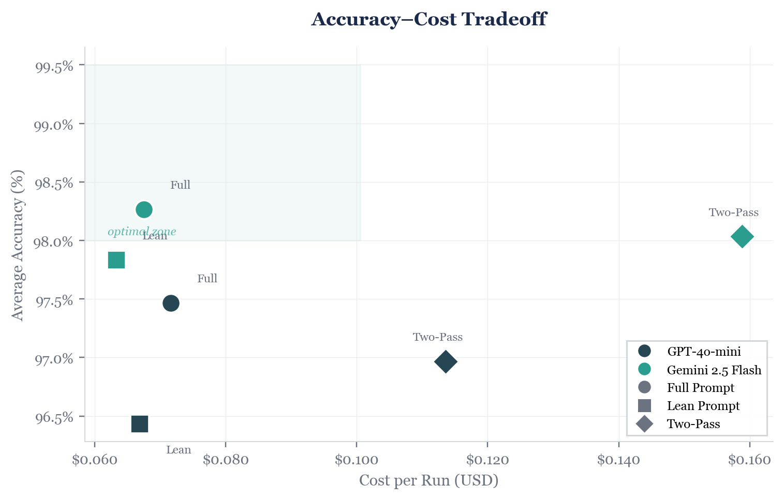
Figure 6. Accuracy vs. cost. Ideal position: upper-left (high accuracy, low cost).
Gemini 2.5 Flash with Full Prompt occupies the optimal position: highest accuracy at the second-lowest cost. Two-Pass strategies cluster rightward (higher cost) without moving upward, indicating poor cost-effectiveness for this task.

5.3 Production Cost Projection
Scenario | Reports | Estimated Cost
Validation set (this study) | 200 | $0.07
Medium clinic network | 10,000 | $3.38
Large dataset (100K) | 100,000 | $33.80
Monthly new reports (est.) | 1,000 | $0.34

The total cost for the entire 6-configuration experiment was $0.54, demonstrating that systematic model evaluation is economically trivial at current LLM pricing. At scale, labeling 100,000 reports would cost approximately $34.

6. Prompt Engineering Insights
- Condition-specific rules are essential: generic prompts achieved only 88–92%; per-condition disambiguation improved accuracy to 95–99%.
- FINDINGS vs CONCLUSIONS hierarchy matters: prioritizing observations over differentials resolved ~3% of misclassifications.
- Edge-case rules have diminishing returns: the Lean Prompt was within 1–2% of Full Prompt for most conditions.
- Cross-condition rules prevent systematic errors (e.g., bronchointerstitial → both bronchitis and interstitial).
- Config-driven architecture enables rapid iteration: JSON-based prompts allow A/B testing without code changes.

7. Remaining Challenges
File Type | Condition | Issue | Root Cause
Canine Thorax | cardiomegaly | 5–7 FPs | Overcalling on any cardiac mention
Canine Thorax | pulmonary_nodules | 3 FNs (50%) | Subtle descriptions missed
Canine Thorax | pneumonia | 0% sensitivity | 1 case; model too conservative
Feline Thorax | focal_caudodorsal_lung | 4 FNs (33%) | Inconsistent caudal mapping
Feline Thorax | left_sided_cardiomegaly | 2 FNs (33%) | Subtle left-sided findings
Canine Abdomen | small_intestinal_obstruction | 1 FN (83%) | Equivocal report language

These errors concentrate in conditions with very few ground-truth positives (1–6 cases), where a single misclassification produces large sensitivity drops.

8. Key Risks
- Small validation set (200 reports, 51 conditions) — low-prevalence conditions have wide confidence intervals.
- Non-determinism — LLM output may vary between runs even at temperature=0 (observed <0.5% variance).
- Vendor dependency — API pricing/availability may change; multi-backend support mitigates this.
- Prompt specificity — new conditions require prompt engineering, not just configuration.
- No "Unsure" category — all cases receive definitive labels, potentially increasing FPs for ambiguous cases.

9. Methodology

9.1 Data
Category | Reports | Conditions
Canine Thorax | 50 | 20
Canine Abdomen | 75 | 10
Feline Thorax | 75 | 21

All reports manually labeled by board-certified veterinary radiologists. Data provided by a veterinary AI company under a research agreement.

9.2 Evaluation Metrics
Per-condition: TP, FN, TN, FP, Sensitivity (TP/[TP+FN]), Specificity (TN/[TN+FP]). Overall accuracy: correct classifications / total condition–report pairs.

9.3 Implementation
Python with asyncio for concurrent API calls. OpenAI AsyncOpenAI client with JSON Schema strict mode; Google genai SDK with structured JSON output. Token usage tracked via response metadata. Full codebase version-controlled in Git.

